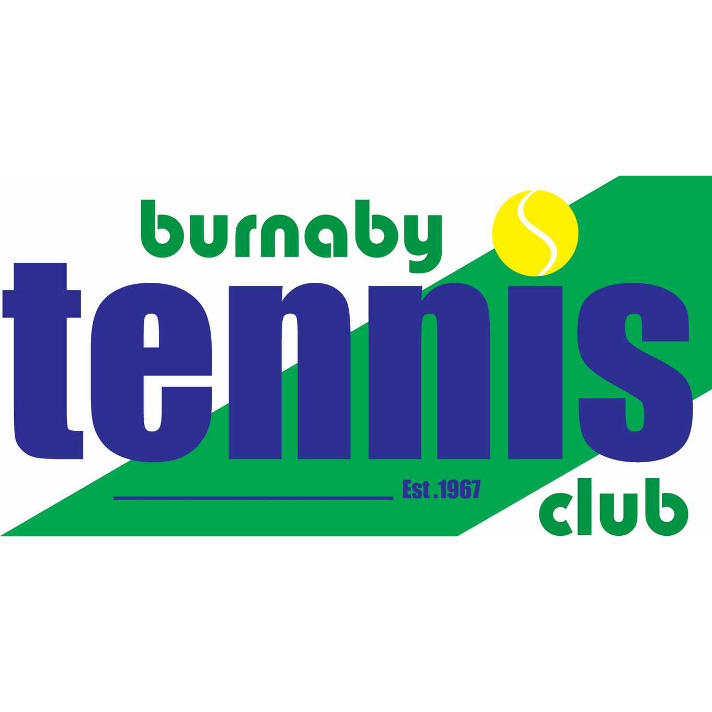

Board Directors
George McLachrie – President  Lawrence Kumar – Vice President  Frank Kusmer – Secretary-absent  David Pel – Treasurer  Graham Youde – Operations Director  Peter Upper – Men’s League Director | Mike Hopkins – Membership Director- absent  Michelle Sing – Women’s League Director  Nick Lee – Tournament Director  Sat Gill – Social Director-absent  Eliza Haight – Club Manager  Vacant – Junior Development Director

- Welcome, call to order & round table – George
- Approval of Past Meeting Minutes-
-Approved minutes from September 11, 2019
- General Board Items – George
Sexual Harassment Tennis BC- send an email out to membership using tennis bc links.
  - Board members status-
  - Open director positions
- Western Canada Training Center – George
-Anita from Tennis Canada to come out in November. We will set up a meeting with the BTC committee as we need to try and be more proactive.
-Will be arranging a meeting with City of Burnaby’s Dave Ellenwood, Dean Pelletier, Lawrence and myself.
-Met with Mark Roberts re: courts and how to promote tennis at Burnaby Lake tennis courts and the lower mainland. Mark will work on something financially and present to BTC. If they can fund BTC, we can have the office can stay open.
-Will get legal opinion on extra funds if BTC is dissolved. Will get lawyer to attend AGM.
Contract for lease with City will be submitted.
-Met with Michelle from BC Wheelchair. Given the recent news of the WTC, Michelle will be reaching out to the Rick Hansen Foundation to discuss options regarding the grant that was given to BTC
-Request from Tennis BC- Sarah Kadi- asking BTC to host and coordinate a NRTP Seniors Tournament
City of Burnaby- approaching BTC regarding booking all courts for a tournament in Sept.
- Communication Next Steps – Michelle
–Next communication will be advising of board positions. Link for sexual harassment video and communication will be included.

- Coaching Status – Nick, Peter, Frank
-Complaint registered by former member regarding coaching status. Board to reply.
-Low coaching court usage due to Jack being away for 3 weeks, he will be back on the 15th.
- Jr programs starting and hoping to see Jr development participants filter into Jr. Clinics.

- Financial Status – Lawrence
- Off to a good start in terms of rapid influx of members and dues. Because bubble opened early we earned extra revenue from Guests, Pay & Play, coaching, as well as public rentals.
- Club Management – Eliza –
- New Ball Machine has been ordered and will be delivered in 2-3 weeks. Start of the season was very busy administratively.
- Facility Status – Graham –
- diesel back up is aging and is not as dependable, next board should consider a back up engine that uses natural gas.
- Social Events – Sat
-New members’ social will be held Thursday October 24, 2019 6-8
- Next Meeting Date – AGM November 13, 2019-
- Adjournment

