Social Director Report – May 13, 2015:
Calendar of events for May/June 2015
Spring Fling Social – May 1st, 2015 cancelled due to death in family

Burnaby Tennis Tournament – June/July
Volunteers required – will send out email looking for support
Silent Auction – looking for donations
Last year’s sponsors
All Court Stringing |  | tennis racquet
 |  | tennis bag
Yokohama Tires |  | 4 new tires
Tonic Sports Wear |  | tennis dress
 |  | top and leggings
 |  | top and skirt
Fortius Sport and Health |  | Personal training session
Fit First Footwear |  | tennis shoes
Three flights of beer at Steamworks
Cosmetic All-Ceramic Crown

Should we produce clothing with BTC logo available for sale (hoodies, t-shirts, golf shirts, caps) at this event?
NEW CLUB LOGO
Decision is required to move forward with logo contest or not? Approx. 1/3 of the membership voted. Should we present the top 3 logos with a 50% minimum requirement in order to make a change?
Logo #5 had the most vote followed by logo #1 and current logo.
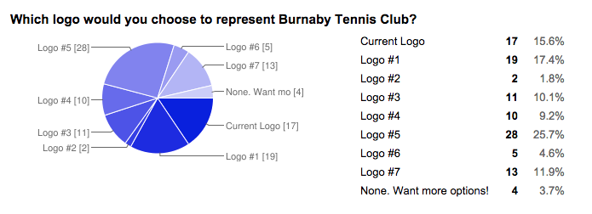
Burnaby Tennis Tournament – June/July
Volunteers required – will send out email looking for support
Silent Auction – looking for donations
Clothing with BTC logo available for sale (hoodies, t-shirts, golf shirts, caps)?

