Membership Director Report – April 13, 2016
- Review of other tennis clubs shows that most common membership categories include adult, senior and junior with some offering family, couple, intermediate and student categories.
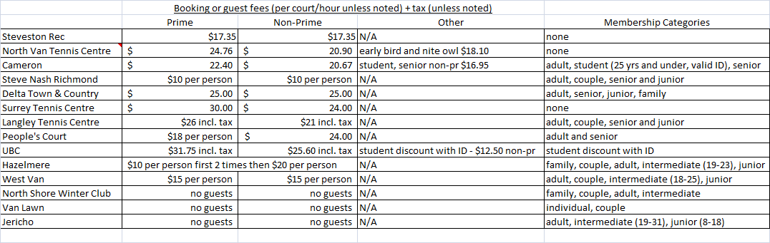
BTC could offer a student category for 25 and under with a valid ID – membership cost could be in between junior and intermediate categories. For example, 2015/16 intermediate (23 and under) fee was $660 and junior (18 and under) fee was $485 – so student could be $550. Future booking system needs to be able to handle an additional membership category. Assume student category would have same booking privileges as intermediate rather than junior. Need to make sure student category is not an option for juniors (i.e. student is for university or college students, not high school students).
- Review of other clubs shows that some have different prime and non-prime booking fees, some have the same for prime and non-prime. A $25 prime and non-prime guest fee for BTC (including tax) would not be out of line with what other clubs charge.
- Advertising deadline for Burnaby Parks and Leisure Fall/Winter 2016/17 Guide is May 13, 2016 with publication in August 2016. I plan to include an ad for BTC as in previous years. Ads in Burnaby Now will go in for August and September.
- Summer-only members will be offered a discount on winter fees. Plan is to approach the summer members later in the summer.
- Summer-only membership for 2016 totals 9 people so far – 1 from Burnaby, rest from Surrey, Vancouver, Coquitlam, Port Coquitlam.
- Attending Volunteer Recognition Night on April 22 with George.
- Will be part of committee to assess new booking system for fall.

