Burnaby Tennis Club
Annual General Meeting Draft Minutes
Wednesday, February 29th, 2012

Directors and Staff Present

Larry Melnyk – President Louie Bortolazzo
Graham Youde – Operations Susan Youde – Social
Val Cuthbert – Secretary David Pell – Director at Large
Rosemary Riley – Junior Development George McLachrie – Membership
Geoff Lakeman – Vice President
Nelson Lu – Treasurer

Rae Smith – Office Manager
Glen Richards – Head Tennis Pro

Absent

Jackie Brown – Tournament Director
Hazel Padula – Ladies League

The quorum was reached. The meeting was chaired by Larry Melnyk, President of the Burnaby Tennis Club (BTC) Board of Directors.

Approval of the minutes of the February 23, 2011, Annual General Meeting (AGM). Motion: Approve the minutes of the February 23, 2011 AGM. Approved.

Adoption of the agenda for the AGM, February 29, 2012. Motion: Approve the 2012 AGM agenda. Approved.

President’s Report – Larry Melnyk

Larry Melnyk welcomed the Board members and the Burnaby Tennis Club members present for taking the time to attend the meeting. He thanked the Board members for volunteering their time and effort. A non profit club such as ours would not survive without hands on volunteer board members that you see before you.

Please give a round of applause to our Office Manager Rae Smith and her staff (Matt, Vivian, Peter, Ronald, David, Nathan, Brad and Sandra)

Thanks to Glenn, Shelley, Rae and all coaching staff for trying to teach us how to play this wonderful game.

Tonight I want to talk about the past, present, and future of this great club. The past will offer perspective and the present will address the most recent season.

History

- The club started in 1968. It was formed by a small band of tennis enthusiasts that secured three courts behind the old Burnaby South School. The present site became the BTC venue during the early 1970’s. The BTC was incorporated as a Society under the Societies Act on May 10, 1972.
- Our clubhouse was built by BTC volunteers and the Burnaby Central shop classes. A used bubble was acquired in the early 1980’s and paid for by floating a debenture. This bubble was replaced by the bubble we play in now. According to Kirk Piper, the current bubble could last another 10 years.
- In the past, all this work was done by members volunteering their time and energy. The bubble was raised and lowered by members for free. Today we pay a contractor, Kirk Piper (Farley group) and we pay another outfit, Storekit, to remove, store and return the bubble to this site each year. The annual cost is about $11,000.00.
- Many tasks are farmed out: accounting, cleaning, maintenance, repairs and improvements. Much is still done by volunteers.
- We have members ranging in age from 4 to almost 100. In fact, until recently, Ed Gladstone was one of the oldest active tennis players on the planet. This is a real United Nations group. BTC members come from every corner of the globe. They play tennis, socialize, get lots of exercise and have fun. There are players of every ability from beginner to elite level. You can always find a game at the BTC: singles, doubles, mixed nights, ladders and men’s night.
- I joined during the early 1980’s. It was enjoyable from the first day and continues to be so because of the tennis and the awesome people. E.g. Who is regarded as the greatest boxer of all time? Did you know that one of our members fought Ali inChicago 1959 just before Muhamed Ali (aka Cassius Clay) won the Olympic Gold. Lindy Lindmosser won the USA light heavyweight title. It’s funny – I never recall getting any bad line calls when I played doubles with Lindy. Lindy was one of the many volunteers that kept the club going in those days.
- We always need people like Lindy to pitch in and carry some of the load in order for this club to be successful. Serving on the board is one way. Offering constructive suggestions is another. Welcoming new members, attending the annual AGM and helping out at the Burnaby Open can only help this club get better.
- What do the following tennis stars (Lleyton Hewitt, David Nalbandian, Jelena Dokic, Gabby Sabatini, Tommy Robredo, Guillermo Coria, Lopez, Volandri, Flavia Pennetta, Martina Hingis, Rick DeVoest, Dementieva, Myskina, and Hurricane Helen Keilesi) all have in common? They all played or hit the tennis ball on our courts (mostly during the world Youth Club September 10 – 14, 1997.)
- The World Police and Firefighter players came from all over to play here a couple of years ago.
- There is a lot of history. This is not a municipal arena, pool or gym where paid civic employees do all the work. It is primarily member volunteers along with a small paid part time staff who do the work and hire key persons when necessary. Let’s build on the past tradition. We have incredible diversity and a huge pool of talent at this club. Let’s tap into this human potential and reap the benefits. Ask what you can do for the club.
The Present
- Outstanding Social events: Susan, Graham, Lori and crew
- Upgrading rules to make the club run smoothly & fair: Rules Committee:
Jackie Brown, Graham Youde, Maria Del Negro, Eng Choo, Gerry Himmelman, Ed Wu,
Louise Schultz
- Gathering membership statistics & advertising: George
- Court buzzer system: Geoff
- Outdoor lighting on pathway & interior emergency lights: Graham
- Interior door latches to secure Bubble at night: Graham
- Wheelchair tennis indoors Monday nights – a first in B.C.
- Responsible financial management and accountability: Nelson & David
- Online reports of minutes: Val
- New court sweeper machine to minimize dust and ball fuzz: Rosemary
- New dishwasher, ladies’ league, day socials, researching specs for a defibrillator, and performance criteria: Hazel
- Handyman work & Improvements: Barry
- HVAC, diesel back-up, & bubble: Graham
- New ball machine: Graham
- Official club t-shirts & hoodies: Graham & Susan
- Men’s league schedules: Louie
- Bubble emergency rescue work: Graham Staff, Larry
- Head Tennis Pro’s contract: Louie, Graham, Larry

The Future – Where are we going from this point on?

- I believe that we are in good financial shape. We are financially prudent and responsible. Our dues are low and provide great value. The dropping of HST in March 2013 can help us keep price increases down.
- The tweaking of the HVAC system has been successful in producing a good internal environment. The back-up system works as was recently demonstrated on the night of February 15, 2012 when there was a power failure. There was virtually no disruption to indoor tennis that night. Although, I was sweating bullets behind the scenes trying to refuel the diesel back-up engine (with Glenn & Brad) and get repair crews out to fix things before the bubble could collapse.
- I see new faces here. People are joining the club because they hear good things about us. We get positive feedback that we are on track and that the club continues to improve. We have a good relationship with the City of Burnaby, contractors and staff.
- Kirk Piper (Farley Group) estimated that our bubble may last at least 10 years. Tears and damage can be repaired in most instances. We can replace the bubble with a new one if necessary for 190K (recent quote from the Farley Group of Guelph,Ontario.) I feel that we have time and money to address that eventuality when it comes.
- I invite you to enjoy the present facilities, low dues, and friendly, enthusiastic members. I ask you to do what you can to improve this club. Get involved. Encourage others.
- I agree to stand for re-election and continue to work really hard for the Burnaby Tennis Club. We need to follow the principal of constant and never ending improvement.

Head Tennis Pro’s Report – Glen Richards

- The Club’s tennis professionals are Glen Richards, Rae Smith, Shelley Roxburgh and Nick Lee.
- We currently the strongest Junior Group ever at the Burnaby Tennis Club. We have 10 – 15 top level juniors.
- Last year’s Burnaby Open was our most successful year. There were 509 entries. We are always looking for volunteers to help with the Open.
- There will be summer camps for Juniors
- The Marj Walters Memorial Trophy recipient this year was Patrick Walker. The trophy goes to the most improved player each year.
- Singles Box ladder is very popular
- Men’s A division were in first place last year
- The rookie tour for children under ten will be offered once or twice per year. They work with Tennis B.C.

Office Manager’s Report – Rae Smith
- The Burnaby Tennis Club purchased a dishwasher, court cleaner, ball machine and staff uniforms
- The Heat in the bubble was comfortable and consistent
- Club hoodies and shirts are for sale in the office
- New vending machine has been ordered
- Making further improvements to the Rules and Regulations
- The club is always working for you. Provide input and we will do our best to carry out your request.

Initiation, Injury and absentee

- Initiation – Members who leave the club and return
Late fee charged $25.00 per season, late fees would not exceed $150.00 initiation fee
- Injury – If member comes into season injured
Must pay all dues up front, needs Doctor’s certificate, when ready to play, notify
Office Manager to get rebate for complete months not played. Rebate is applied
against next years’ dues
- If injured during the season. Notify the Office Manager, needs Doctor’s certificate, when ready to play, notify Office Manager to get rebate for complete months not played. Rebate is applied against next years’ dues.

Absentee
- Persons who are gone for the season. Pay $100.00 which holds your initiation until you return.

Treasurer’s Report – Nelson Lu
- The court rentals have not generated as much revenue as the last year.
- Financial Reports are attached at the end of the minutes.
- Motion to accept the financial reports moved by Mark Sun, seconded by Ted Sederis – Motion Carried.
Director’s Reports:
- Vice President – Geoff Lakeman
  - Installed new clock and hourly buzzer. This reduced timing conflicts and walk on traffic
  - Virtual phone attendant being investigated. This would route calls to the appropriate voice mail boxes. E.g. head pro, office manager, etc.
  - Forward voice mail to text or e-mail
  - Not a budgeted item

- Secretary – Val Cuthbert
• The minutes are posted on the Club’s Website and there is a paper copy in the office. They are one month behind each month as they must be approved the following month before posted.
• If members require further clarification on any items from the minutes, they should contact the appropriate Board member.

- Operations – Graham Youde
• Successful year
• No bubble accidents
• Signed new 3 year maintenance agreement
• Installed high efficiency lighting on walkways and bubble entrance. This is more cost efficient.
• New weather stripping around emergency doors to reduce heat loss
• Diesel back-up overhauled to ensure prompt emergency start-up
• Installed timers on all lights inside clubhouse and on walkway
• Supplied staff with BTC clothing to clean up their appearance
• New wiring in the annex to accommodate new court cleaner
• Purchased new ball machine, sold the old one for parts
• Some of the clocks in the Bubble are not working. Graham will look into this.

d. Membership – George McLachrie
• Responsible for encouraging growth of membership (limit 300+-), retaining current members, keeping tabs on membership trends, researching demographics and needs of members, assisting in determining the eligibility of applicants for membership
• Handling club publicity
• Being available to promote the club during annual recruitment drive at the end of summer
• Dealing with membership issues: dues (recommendations), caps on numbers and members not in good standing etc.

Membership Campaign 2011/2012

• At the end of summer 2011 there were many rumors of dissatisfaction from the members. Many members would not be renewing their memberships due to the new rules and regulations and enforcement of the rules. At the end of November sixty-five members chose not to renew their memberships. This is not an unusual turnover; further this year’s campaign for new members didn’t include a “waiver of the initiation fees” used in the 2011 promotion for new members. Val Cuthbert and I implemented a personal call campaign to each member who didn’t renew. A survey containing four questions was used for each call.
• This call campaign determined that the rules had nothing to do with members leaving and not renewing with the exception of 2 people. Reasons ranged from: loss of job, moving away, job change, reducing time and lack of usage. All were happy with the club, the members and how the club was run.
Demographics
• Thanks to club staff (Ronald and Nathan Mach) we were able to do an analysis of our membership (Graphic attached).
· Interesting uses can be made of this data, for example:
Advertising campaigns to target market, confirmation for the City of Burnaby to use as
potential information for funding, promotional campaigns and for social and
tournament events.
· We have 305 members currently. 82% of the membership is from Burnaby, Vancouver, Coquitlam and New Westminster. This confirms the continued interest in tennis for this area and the strong growth possible. See graphs below.
Club Publicity- Advertising Campaign
• Purpose to draw attention to our club (Burnaby Parks and Recreation)
• Maintain constant level of membership and attract new members
• Keep fulfilling our mandate for 25% of Court time for Burnaby residents/tax payers
• BTC staff will measure results

Giga Sports
We met with the Giga Sport Executive this past summer to present and inform us of their
updates and assistance to meet BTC requirements. This is an ongoing program by staff and
board members.

Member Issues:
Mostly minor calls and letters needed to respond to issues and only one collection issue that was dealt with by Rae. There were no serious disciplinary issues.
Member Assistance Required
We seek your co-operation and assistance to provide detailed information on the application forms which will help us to plan for better programs, and allow us to tap into the power of the talent in our club with advice and program contributions. Simple things such as your age and current profession or work experience or in the case of retirees, your former work or profession, would be extremely valuable for us. Please at least provide your residence and contact information.

Goals for 2012-2013 (Balance of term)
• Empower membership to increase and participate in club activities and projects
• Empower members to be more proactive to assist the board on issues
• Provide more media exposure in the Burnaby News (Rick Keffer follow-up)
• Create a new survey of membership before summer (add on Rick Keffer 2010 survey)
• Provide more signage around the club premises to inform casual players to join as a member
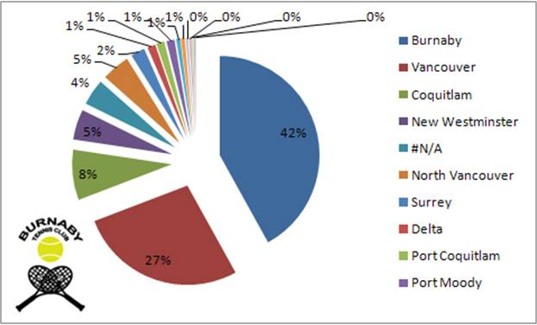
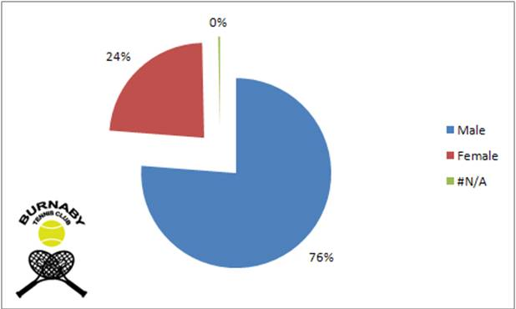
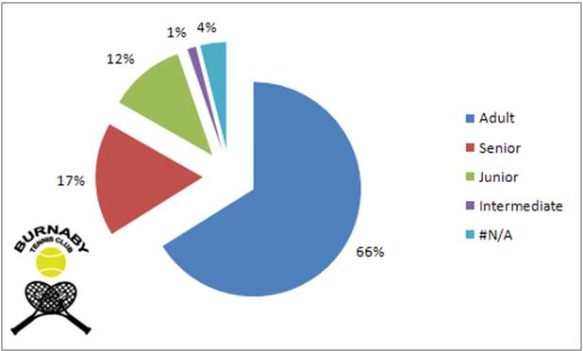

e. Junior Development – Rosemary Riley

• Has been running on alternate Saturdays for 20 years
• Includes non-member juniors
• Currently the strongest junior group ever at BTC
• Some are on our Men’s A league team that won last year
• Programs include high performance camps, rookie tour events, weekly summer camps, etc.
• Have 10 – 15 top level juniors, some are playing the Nationals

f. Socials – Susan Youde

• The social events were well attended
• All events were virtually sell outs
- March – Hawaiian Luau
- May – Viva Las Vegas
- October – Ghouls and Goblins Halloween
- Dec – Groovin’ With the Grinch Christmas
- Jan – Chinese New Year

• Entertainment
- Limbo contest, Elvis impersonator, Magician, Karaoke, Trivia

g. Ladies’ League – Hazel Padula

2011 Spring League
• Night Division 1 – 2nd place finish
• Night Division 3 – 3rd place finish
• Day Division 3 – On leave of absence, unable to resolve lack of players, no response from new members, decided to dissolve day 3 team. The remaining players are now sparing for or joining night divisions.

Socials
• Day socials well attended
• Many new members attended the last social. There were equal numbers of ladies and men
• Thanks to Rae and Staff, Glenn, Lori and all those who attended
• Day and Night Social Events. They is a great mix and they are a lot of fun

h. Men’s League – Louie Bortolazzo

• A Division – Champions
• B1 Division – 5th place
• C1 Division – 5th place
• Senior League – 3rd place

This year a total of 51 men participated. We continue to be very well represented by both current and new members each year. All spring league teams begin play in mid-March until June. Anyone interested in participating can get the Captain’s contact information from Glenn

i. Tournaments – Jackie Brown

Two Tournaments hosted at BTC in 2011
• Burnaby Open
• Annual Burnaby Club Tournaments

Burnaby Open
• Most successful year with 509 entries
• Most rain delays in 9 year history of this event
• City of Burnaby power-washed front 11 courts
• Small core group of volunteers
• BTC profits from this large event
• Largest tournament after Stanley Park

Burnaby Club Tournament
• 50 entries in singles and doubles
• Sign-up sheets for 2012 will be up in late March

Business Arising from Last AGM

• Secure entry for bubble implemented
• Looked into various booking schemes – decided to stay with 1 hour blocks
• Booking rules - A committee was formed focusing on improvement and enforcement
• Discussed need to find more robust booking software (consulted current provider, Giga Sports)

Election of Directors

President – Larry Melnyk
Vice President – Geoff Lakeman
Operations – Graham Youde
Social Director – Susan Youde
Treasurer – Nelson Lu
Ladies League – Hazel Padula
Junior Development – Mark Sun

Rosemary Riley decided not to stand again for the Junior Development position. Larry thanked her for all of work that she has contributed to the Club while on the Board.

Other Business
a. Future plans – George McLachrie/David Pell

Report to Membership of the Tennis Club of Burnaby,

Members:
The Board wishes to evaluate the feasibility of a permanent tennis structure for the Burnaby Tennis Club. The interest of the Board was generated by presentations made by Tennis BC and a presentation by the operator of the tennis facility in Langley adjacent to the Langley Events Centre.
Members of the Board came to realize that the operating cost of the latest fabric structure is dramatically less than the bubble technology as we currently operate. Some of the advantages identified with the new technology fabric structures are, that they do not require a blower to keep the structure intact. Less emergency maintenance in that a hole, as a result of wind, vandalism or snow does not result in the structure collapsing.
This evaluation process will require discussions with the City of Burnaby and expertise to evaluate the soil conditions and an estimate of the cost of erecting the structure. The report will attempt to determine if this new structure can be put in place without any significant increase in member dues. We will attempt to determine if there is Federal, Provincial or Municipal grants that would assist in offsetting the cost of creating this structure.
We are looking for the support of the club membership and hope to be able to draw on members for assistance.

There was agreement from the members to go ahead with a feasibility study.

- Water in the courts
Since the highway changes took place there appears to be more water running through the courts. This needs to be looked into.
- Bubble Doors
When entering the bubble, the doors slam. It was suggested that the club look at a hydraulic arm. This will be discussed at the next board meeting.

Next Annual General Meeting – Wednesday, February 27, 2013

