BTC 2016/17 Membership as of November 5, 2016
- Membership total as of Nov.5, 2016 is 304 (including 22 pay and play)
- Last year’s total (by January 2016) was 294 (including 30 pay and play)
- New members equals 33
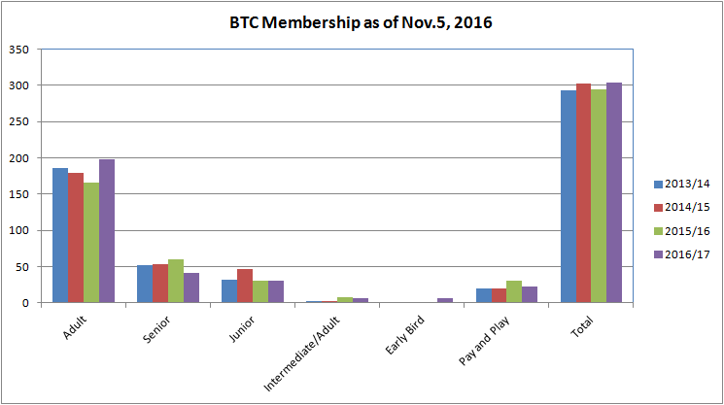

- Burnaby-residents share continues to be close to 50%
- This level is similar to last year but improved since 2013/14 level of 43%
